6.1.1
Problem Statement
Write a Python program to check if a given date is valid. If the date is valid, print the next day's date (incremented date). If the date is invalid, print "Invalid Date".
Algorithm
- Start.
- Read day, month, and year from the user.
- If year ≤ 0 → Print "Invalid Date" → Stop
- If month < 1 OR month > 12 → Print "Invalid Date" → Stop
- If (year % 400 == 0) → Set leap = True
- Else if (year % 100 == 0) → Set leap = False
- Else if (year % 4 == 0) → Set leap = True
- Else → Set leap = False
- If month is 1, 3, 5, 7, 8, 10, or 12 → Set max_day = 31
- Else if month is 4, 6, 9, or 11 → Set max_day = 30
- Else if month == 2 → If leap == True → Set max_day = 29 → Else → Set max_day = 28
- If day < 1 OR day > max_day → Print "Invalid Date" → Stop
- Increment day by 1
- If day > max_day → Set day = 1 → Increment month by 1
- If month > 12 → Set month = 1 → Increment year by 1
- Print "Next Date is: day/month/year"
- Stop.

Flowchart:
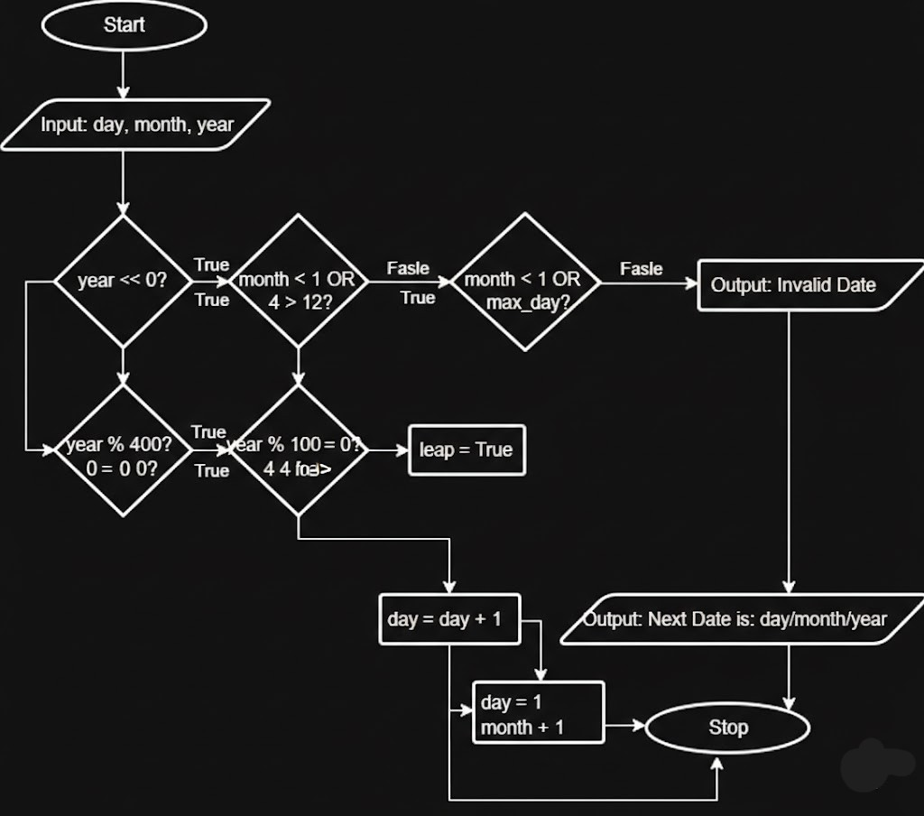
EXECUTION:
